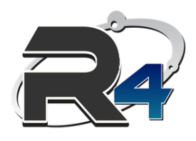

| Teledental Project- phase II |
| --- |
| Design Document |
| Picture Validation |



**Contents**

**Picture Submission Requirements** 3

**Picture Validation Requirements** 3

**Required API’s** 4

**Picture Validation Workflow** 5

# **Picture Submission Requirements**

* + 1. Need system capability to capture pictures of the mouth
    2. Requires 2 Pictures:
       - 1. Smile
         2. open mouth to see back teeth
    3. *Open* and *Smile* pictures are required for patients older than one year. Patients younger than 12 months only need one ‘open’ mouth picture.
    4. Provide some examples of what expectation is, similar to process of depositing checks via phone, how to do camera angle
    5. Member to approve pictures and then submit
    6. Members must accept or retake photo.
    7. Require Accept Retake functionality
    8. If Pictures are not submitted, then Member cannot proceed
    9. Need system to provide picture validation
    10. Completion of form--Submit

# **Picture Validation Requirements**

1. System validates the quality factors based brightness, and clarity. End users should be informed the reason of their photos rejection based on brightness and clarity (blurriness).

## Quality Validation Requirements

System validates the **overall quality** of the photo based on brightness/contrast and clarity (blurriness). The way the factors are being evaluated is via BRISQUE for blurriness and light pixel values for brightness. Finally, ML models were used to predict the final values (True/False) for each factor.

Here is an example of a photo passing **both requirements:**

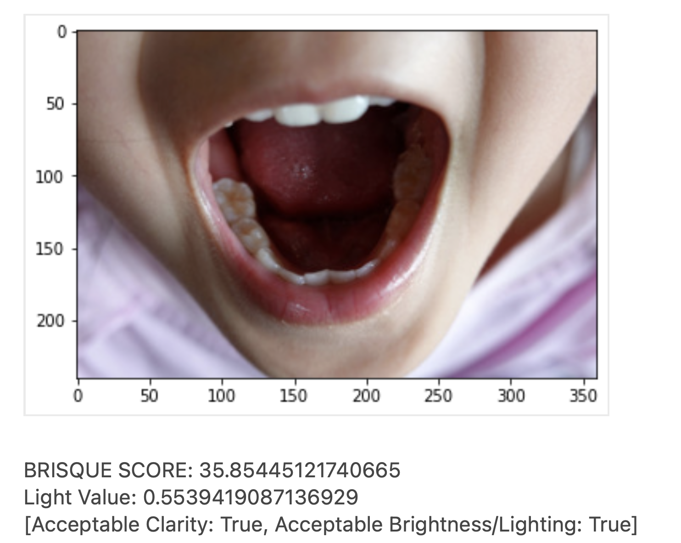

Here is an example of a photo failing **both requirements:**

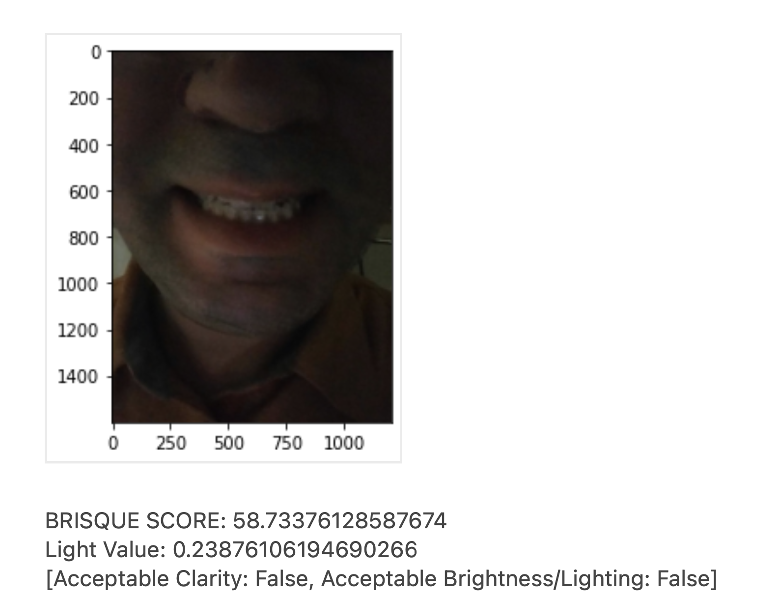

Here is an example of a photo failing **Clarity ONLY:**

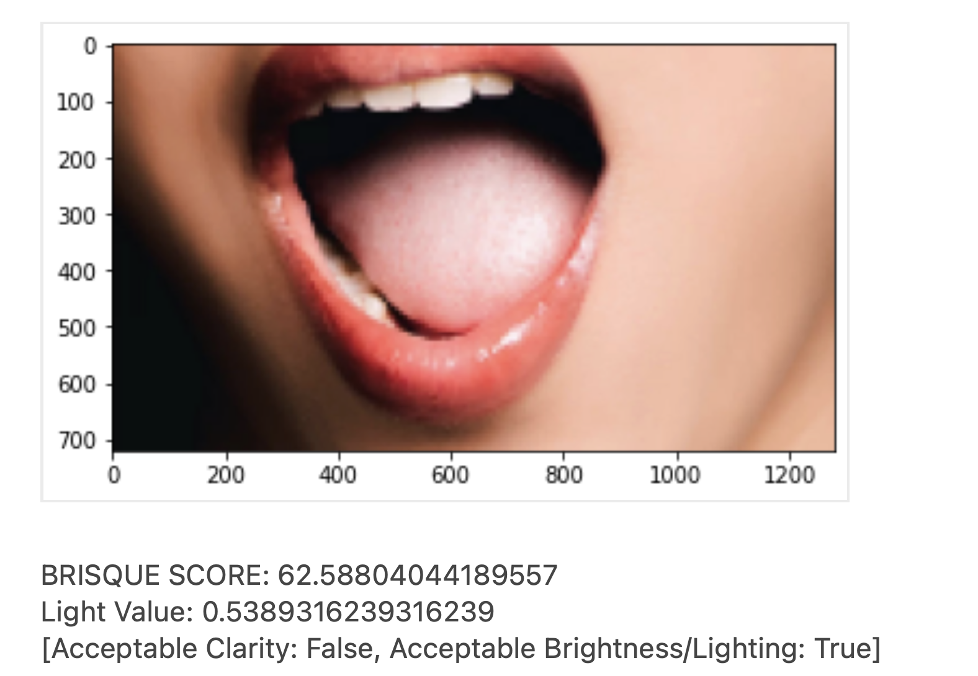

Here is an example of a photo failing **Brightness ONLY:**

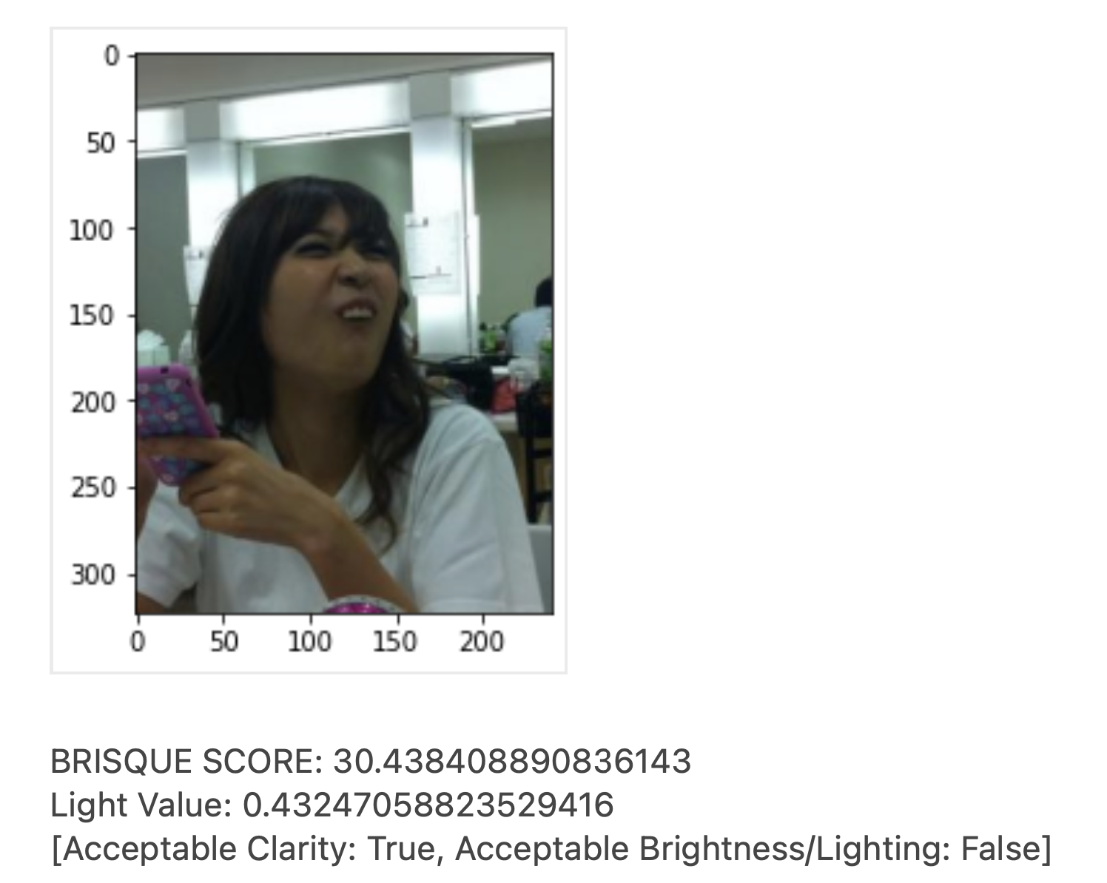

## Content Validation Requirements

System validates if the picture is properly taken from either *smile angle* or *open mouth* angle. The acceptable area of the face is between the nose tip and the chin.

* In the smile angle, **the upper and lower front teeth** should be visible. Here is an example:

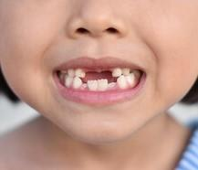

* In the open angel, the **lower back teeth** should be visible. Having the upper front teeth is optional. Here is an example:

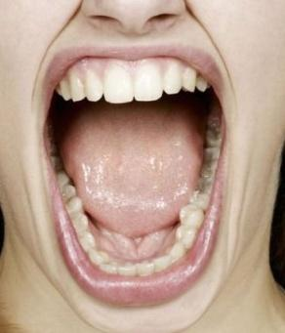

* A mouth is labeled ‘open’, if its height is $\frac{1}{3}$ or less than of its width as shown in the below:

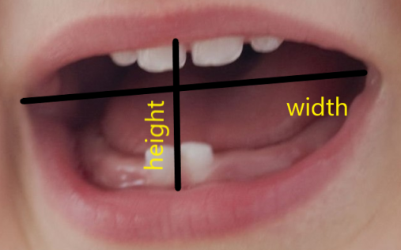

1. The face should be completely in front of the camera without any angle to left or right.

* Here is a not acceptable example:

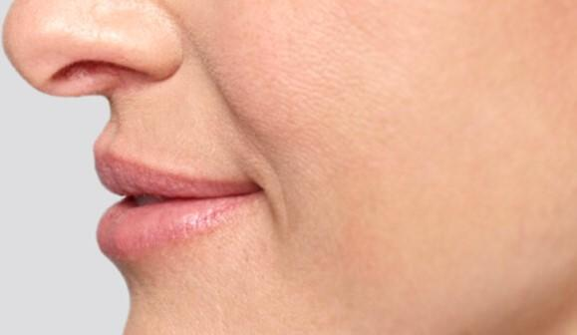

* The whole face and beyond are not acceptable. Here is a example:

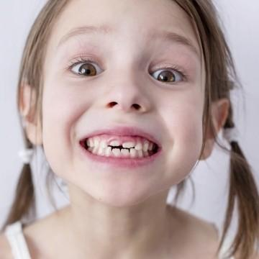

# **Required API’s**

 Two API’s are required for the picture validation workflow:

1. **Quality Validation API:** In this API, the quality of submitted photos by end users (members) will be validated. The BRISQUE method is the main quality assessment method used for the quality validation.

| Name | ValidateQuality |
| --- | --- |
| Method | post |
| input | { "ImagePath" : "<https://fileserver/images/child1smile.jpg>" } |
| Uri | <https://teledentalapi.libertydentalplan.com/validatesmile> |
| output | {"Acceptable Brightness": True/ False }  {"Acceptable Clarity": True/ False } |

1. **Angle Validation API:** In this API, validates if the picture is properly taken from either smile angle or open mouth angle. The API rejects irrelevant photos taken from other objects which not include a human being mouth. To validate the angle of the mouth, a classification model will be applied.

| Name | ValidateAngle |
| --- | --- |
| Method | post |
| input | { "ImagePath ": "<https://fileserver/images/child1mouth.jpg>" } |
| Uri | <https://teledentalapi.libertydentalplan.com/validateopenmouth> |
| output | {"Acceptable Open Angle": True/False}  {“Acceptable Smile Angle": True/false } |

# **Picture Validation Workflow**

